Low-Level Design (LLD) — Industry Segment Module
Attribute | Value
Module | Industry Segment (System Config Master)
Menu path | ADMINISTRATION → Industry Segment
Landing page | industry_segments.php
Application | Complaint / Dealer Portal
Stack (target) | Core PHP + MySQL (PDO)
Stack (current repo) | Core PHP + PostgreSQL via PDO
Document version | 1.0
Access | System Admin only (role id 6) — no RBAC module slug
Architecture | Shared SCM stack ($scmType = 'industry_segment')

â”€â”€â”€â”€â”€â”€â”€â”€â”€â”€â”€â”€â”€â”€â”€â”€â”€â”€â”€â”€â”€â”€â”€â”€â”€â”€â”€â”€â”€â”€â”€â”€

1. Module Overview

1.1 Purpose
System Administrators maintain industry segment options in industry_segments for Installed Base Capture. The module is a thin SCM wrapper: list/create/edit/details/soft-delete share system_config_master_* pages, helpers, APIs, and JS. Installed Base stores the selected name string (not an FK id).

1.2 Scope
In scope | Out of scope
List / Add / Edit / Details / Soft-delete | Complaint Entry (does not use this master)
Active / Inactive status | Hard delete
Case-insensitive name uniqueness | Dedicated industry_segment_helpers.php (uses SCM helpers)
Create abuse / rate-limit guard | Cascading rename/delete to installed_base
Active names for IB Select2 | Other SCM types (Warranty, Part Replaced, etc.)

1.3 High-level architecture
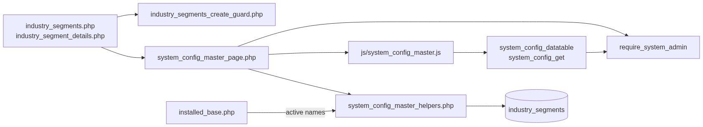
Figure 1 — High-level architecture
â”€â”€â”€â”€â”€â”€â”€â”€â”€â”€â”€â”€â”€â”€â”€â”€â”€â”€â”€â”€â”€â”€â”€â”€â”€â”€â”€â”€â”€â”€â”€â”€

2. Functional Requirements
ID | Requirement | Priority
FR-01 | System Admin can open Industry Segments list (DataTables) | Must
FR-02 | Create industry segment with name and status | Must
FR-03 | Edit via inline slide-down form | Must
FR-04 | Soft-delete; hide from list | Must
FR-05 | Unique name among non-deleted (case/trim-insensitive) | Must
FR-06 | Filter / search list; status active/inactive | Should
FR-07 | View read-only details + audit fields | Should
FR-08 | Throttle / rate-limit create requests | Should
FR-09 | Client validate.js for name + status | Should
FR-10 | Expose active names to Installed Base dropdown | Must

â”€â”€â”€â”€â”€â”€â”€â”€â”€â”€â”€â”€â”€â”€â”€â”€â”€â”€â”€â”€â”€â”€â”€â”€â”€â”€â”€â”€â”€â”€â”€â”€

3. User Roles & Permissions

3.1 RBAC module slug
None. Industry Segment administration is gated by System Admin (SYSTEM_ADMIN_ROLE = 6), not a permission slug.

3.2 Permission matrix
Capability | Gate
All Industry Segment admin pages | require_system_admin($obconn) (via SCM page)
SCM APIs with type=industry_segment | admin_api_require_system_admin
Denied | Access denied. System Admin privileges required.

Pages (industry_segments.php, industry_segment_details.php, delete_industry_segment.php) are in rbac_admin_pages() and skip module RBAC; System Admin check is authoritative.

3.3 Page / API mapping
Resource | Gate
industry_segments.php | System Admin
industry_segment_details.php | System Admin
delete_industry_segment.php | System Admin
api/system_config_datatable.php?type=industry_segment | System Admin API
api/system_config_get.php?type=industry_segment | System Admin API

3.4 Consumer access
Installed Base users need Installed Base module permissions (separate). They only see active, non-deleted names via scm_get_active_names('industry_segment') / installed_base_industry_segments().
â”€â”€â”€â”€â”€â”€â”€â”€â”€â”€â”€â”€â”€â”€â”€â”€â”€â”€â”€â”€â”€â”€â”€â”€â”€â”€â”€â”€â”€â”€â”€â”€

4. Business Rules
ID | Rule
BR-01 | Soft-deleted rows excluded from list, get, uniqueness, and IB options.
BR-02 | Name unique among non-deleted: LOWER(TRIM(name)); edit excludes self.
BR-03 | Soft-deleted names may be reused on create.
BR-04 | Status must be active or inactive.
BR-05 | Inactive names stay in admin list but are not offered in Installed Base.
BR-06 | Soft-delete / rename does not update existing installed_base.industry_segment values.
BR-07 | No “in use” check before soft-delete.
BR-08 | Create-only abuse guard: max 1/request; min 3s interval; max 20 creates / 15 min.
BR-09 | Edit requires existing non-deleted row.
BR-10 | created_by = current_username() on insert; created_at / updated_at timestamps.
BR-11 | Details/delete URL ids are base64_encode((string) id).
BR-12 | Create/update stay on page (no PRG). Delete redirects to list with session flash.
BR-13 | Installed Base stores the name string, not industry_segments.id.
BR-14 | SCM type key is industry_segment; table industry_segments; submit key submit_industry_segment.

â”€â”€â”€â”€â”€â”€â”€â”€â”€â”€â”€â”€â”€â”€â”€â”€â”€â”€â”€â”€â”€â”€â”€â”€â”€â”€â”€â”€â”€â”€â”€â”€

5. Database Design

5.1 ER diagram
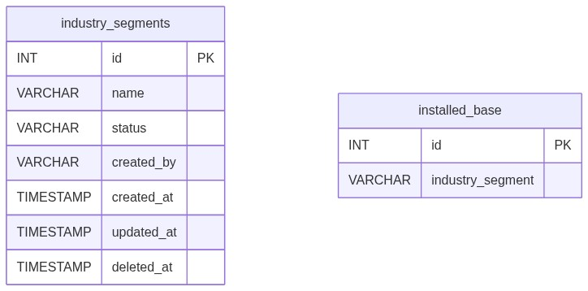
Figure 2 — Entity relationship diagram
Logical link (name string, not FK):
Figure 3 — Denormalized name link to Installed Base

5.2 Table: industry_segments
Column | MySQL type | Notes
id | INT UNSIGNED AUTO_INCREMENT | PK
name | VARCHAR(100) | Required; unique among non-deleted
status | VARCHAR(20) | active / inactive
created_by | VARCHAR(100) | Creator username
created_at | TIMESTAMP | Insert
updated_at | TIMESTAMP NULL | Update / soft-delete
deleted_at | TIMESTAMP NULL | Soft-delete

5.3 Related tables
Table | Role
installed_base | Consumer; stores name in industry_segment

5.4 Reference / lookup sources
Source | Usage
scm_registry()['industry_segment'] | Labels, pages, table, submit key
rbac_status_options() | Status <select>
scm_get_active_names('industry_segment') | IB dropdown
installed_base_industry_segments() | IB helper wrapper

â”€â”€â”€â”€â”€â”€â”€â”€â”€â”€â”€â”€â”€â”€â”€â”€â”€â”€â”€â”€â”€â”€â”€â”€â”€â”€â”€â”€â”€â”€â”€â”€

6. API / Backend Design

6.1 Page endpoints
Endpoint | Method | Auth | Description
industry_segments.php | GET | System Admin | List + Add/Edit panel
industry_segments.php | POST submit_industry_segment | System Admin | Create or update
industry_segment_details.php?id= | GET | System Admin | Read-only details
delete_industry_segment.php?id= | GET | System Admin | Soft-delete

Wrappers set $scmType = 'industry_segment' and include shared SCM templates.

6.2 JSON APIs

POST api/system_config_datatable.php
Body/query includes type=industry_segment. Server-side DataTables over industry_segments where deleted_at IS NULL.
{
"draw": 1,
"recordsTotal": 10,
"recordsFiltered": 2,
"data": [{ "id": "#1", "name": "...", "status": "...", "actions": "<html>" }]
}

GET api/system_config_get.php?type=industry_segment&id=
Returns row for edit form population. System Admin API gated.

6.3 Supporting lookup APIs
N/A for admin UI. Installed Base loads active names server-side into Select2 options.

6.4 Core PHP responsibilities
File | Role
industry_segments.php | Create-guard hook + $scmType wrapper
includes/system_config_master_page.php | Shared list/form POST handler
includes/system_config_master_details_page.php | Shared details
includes/system_config_master_delete.php | Shared soft-delete
includes/system_config_master_helpers.php | Registry, validate, CRUD, options
includes/module_create_guards/industry_segments_create_guard.php | Create throttle / rate limit
includes/admin_access_helpers.php | System Admin gate

â”€â”€â”€â”€â”€â”€â”€â”€â”€â”€â”€â”€â”€â”€â”€â”€â”€â”€â”€â”€â”€â”€â”€â”€â”€â”€â”€â”€â”€â”€â”€â”€

7. Validation Rules

7.1 Server-side (scm_validate + uniqueness + create guard)
Field / rule | Message
Name empty | Industry Segment name is required.
Name > 100 | Industry Segment name cannot exceed 100 characters.
Status missing/invalid | Status is required.
Duplicate name | Industry Segment name already exists. Please choose a different name.
Missing edit target | Industry Segment not found or already deleted.
Create throttle | Please wait a few seconds before creating another record.
Rate limit | Create rate limit exceeded. You may create up to 20 records every 15 minutes...
Bulk payload | Too many records in a single request. A maximum of 1 record(s)...

Installed Base consumer: Industry Segment is required. / Invalid Industry Segment selected.

7.2 Client-side (js/system_config_master.js)
â€¢ validate.js: Name required + max 100; Status required
â€¢ Edit load failure: Failed to load record details.
â€¢ Success alert fades after 3s
â€¢ Status is native <select> (no Select2 on master)
â”€â”€â”€â”€â”€â”€â”€â”€â”€â”€â”€â”€â”€â”€â”€â”€â”€â”€â”€â”€â”€â”€â”€â”€â”€â”€â”€â”€â”€â”€â”€â”€

8. UI Screen Specifications

8.1 Listing — industry_segments.php
Element | Spec
Subtitle | Manage industry segment options for installed base.
Placeholder | e.g. Manufacturing
CTA | Add / Cancel (SCM form card #scmFormCard)
Grid | #scmTable — ID, Name, Status, Created At, Action
Actions | View / Edit / Delete (confirm('Delete this record?'))
Icon | bi-building

8.2 Form panel
Fields: Name*, Status* (active / inactive).
Hidden: record_id, submit_industry_segment, SCM type wiring via scm_page_js_config.

8.3 Details — industry_segment_details.php
Name, status badge, created by, created/updated timestamps (shared record-details layout).

8.4 Modals / Select2
â€¢ No CRUD modals on master.
â€¢ Admin: native status select — no Select2.
â€¢ Installed Base: Select2 on #industrySegmentSelect (consumer).
â”€â”€â”€â”€â”€â”€â”€â”€â”€â”€â”€â”€â”€â”€â”€â”€â”€â”€â”€â”€â”€â”€â”€â”€â”€â”€â”€â”€â”€â”€â”€â”€

9. Database Flow

9.1 Create
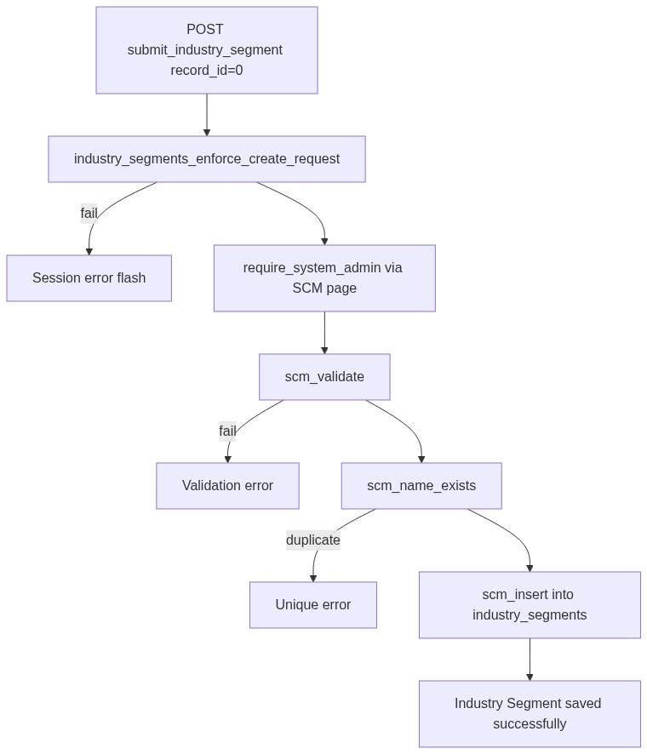
Figure 4 — Create database flow

9.2 Soft-delete
UPDATE industry_segments
SET deleted_at = CURRENT_TIMESTAMP,
updated_at = CURRENT_TIMESTAMP
WHERE id = :id
AND deleted_at IS NULL;

9.3 Active options for Installed Base
SELECT name
FROM industry_segments
WHERE deleted_at IS NULL
AND status = 'active'
ORDER BY created_at ASC, id ASC;
â”€â”€â”€â”€â”€â”€â”€â”€â”€â”€â”€â”€â”€â”€â”€â”€â”€â”€â”€â”€â”€â”€â”€â”€â”€â”€â”€â”€â”€â”€â”€â”€

10. Sequence Diagram

10.1 Create industry segment
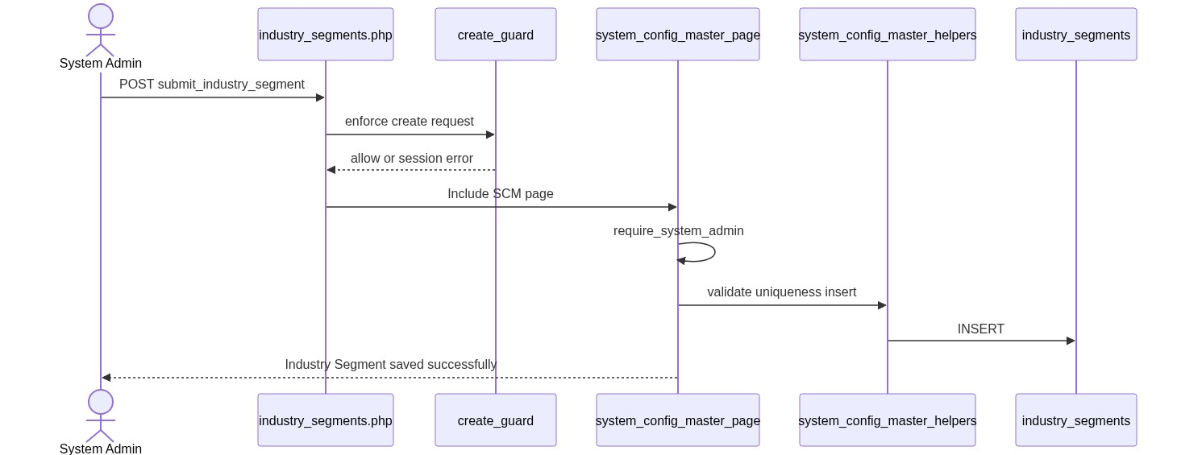
Figure 5 — Sequence: Create industry segment

10.2 Soft-delete and Installed Base impact
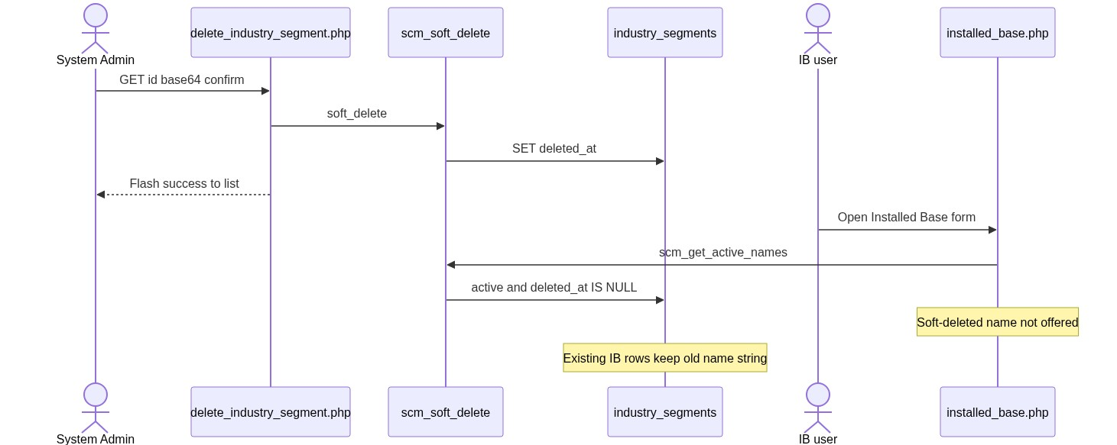
Figure 6 — Sequence: Soft-delete and IB impact
â”€â”€â”€â”€â”€â”€â”€â”€â”€â”€â”€â”€â”€â”€â”€â”€â”€â”€â”€â”€â”€â”€â”€â”€â”€â”€â”€â”€â”€â”€â”€â”€

11. Activity Diagram
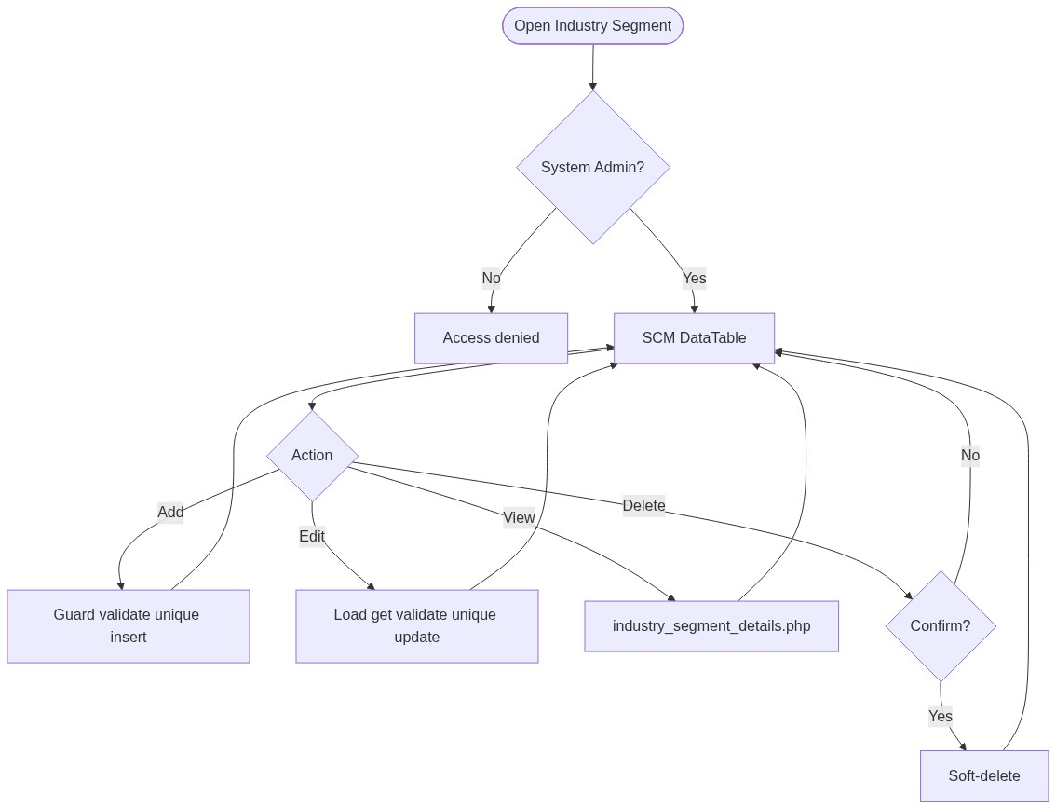
Figure 7 — Activity diagram
â”€â”€â”€â”€â”€â”€â”€â”€â”€â”€â”€â”€â”€â”€â”€â”€â”€â”€â”€â”€â”€â”€â”€â”€â”€â”€â”€â”€â”€â”€â”€â”€

12. Class / Module Diagram
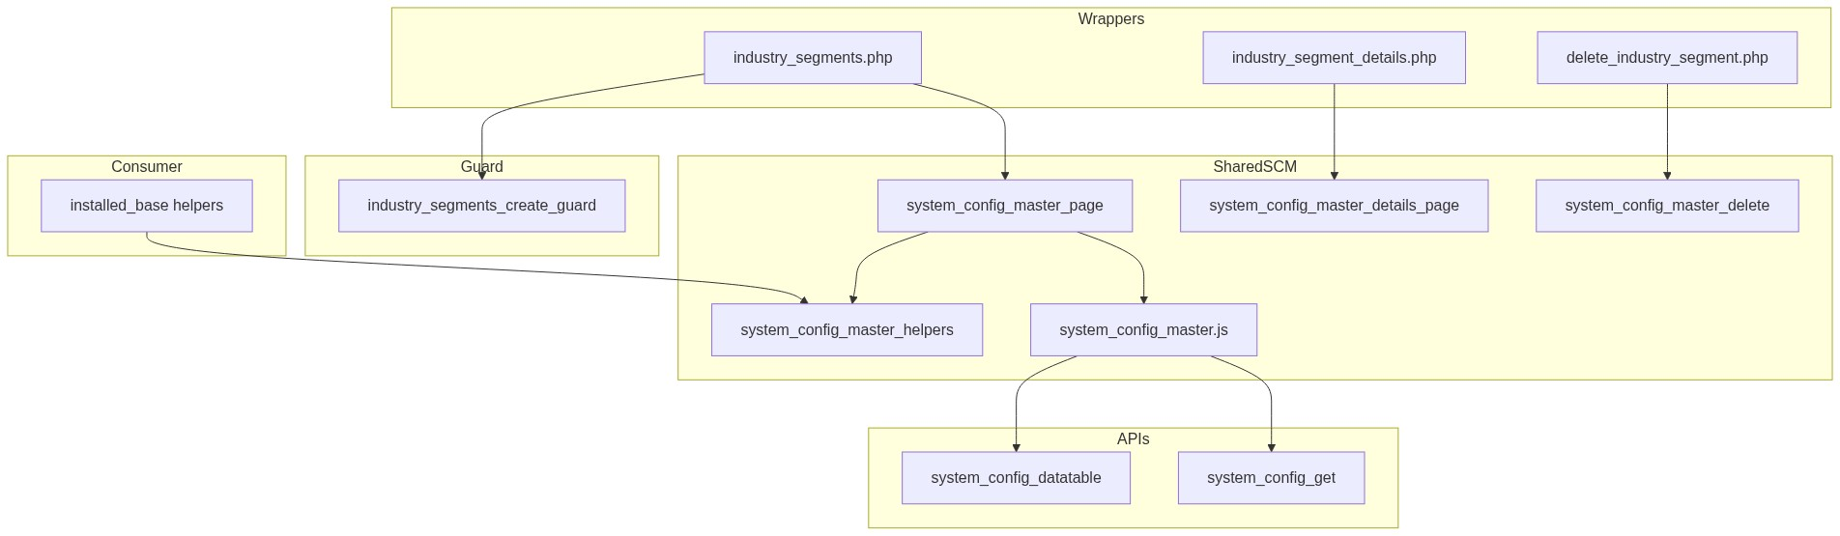
Figure 8 — Class / module diagram

12.1 Key functions
Function | Role
scm_registry / scm_config | Type → table/pages/labels
scm_safe_table | Whitelist table name
scm_from_post / scm_validate | Parse + validate
scm_name_exists | Uniqueness
scm_insert / scm_update / scm_soft_delete | Persist
scm_get_by_id / scm_get_active_names / scm_option_exists | Reads
scm_entry_actions / scm_page_js_config | UI/API wiring
industry_segments_enforce_create_request | Create abuse guard
installed_base_industry_segments | IB active-name options
require_system_admin | Access gate

â”€â”€â”€â”€â”€â”€â”€â”€â”€â”€â”€â”€â”€â”€â”€â”€â”€â”€â”€â”€â”€â”€â”€â”€â”€â”€â”€â”€â”€â”€â”€â”€

13. Folder Structure
ComplaintManagement/
├── industry_segments.php
├── industry_segment_details.php
├── delete_industry_segment.php
├── api/
│ ├── system_config_datatable.php
│ └── system_config_get.php
├── includes/
│ ├── system_config_master_helpers.php
│ ├── system_config_master_page.php
│ ├── system_config_master_details_page.php
│ ├── system_config_master_delete.php
│ ├── admin_access_helpers.php
│ ├── admin_api_guard.php
│ └── module_create_guards/
│ └── industry_segments_create_guard.php
├── js/
│ └── system_config_master.js
├── storage/
│ └── request_abuse/industry_segments/
└── docs/
└── LLD_Industry_Segment_Module.md
â”€â”€â”€â”€â”€â”€â”€â”€â”€â”€â”€â”€â”€â”€â”€â”€â”€â”€â”€â”€â”€â”€â”€â”€â”€â”€â”€â”€â”€â”€â”€â”€

14. Error Handling
Layer | Pattern
Create guard fail | $_SESSION['error_message']; POST submit unset
Page POST | Inline / session success or error via SCM page
Delete | Session flash → industry_segments.php
Details invalid | die('Invalid record.') / die('Industry Segment not found.')
APIs | JSON + HTTP 403/404
Create guard log | storage/request_abuse/industry_segments/

14.1 Common messages
Message | When
Industry Segment saved successfully. | Create
Industry Segment updated successfully. | Update
Industry Segment deleted successfully. | Soft-delete
Failed to save industry segment. / Failed to update... / Failed to delete... | Persist fail
Industry Segment not found or already deleted. | Missing target
Industry Segment name already exists... | Unique violation
Invalid record. | Bad delete id
Access denied. System Admin privileges required. | Non-admin

â”€â”€â”€â”€â”€â”€â”€â”€â”€â”€â”€â”€â”€â”€â”€â”€â”€â”€â”€â”€â”€â”€â”€â”€â”€â”€â”€â”€â”€â”€â”€â”€

15. Security Considerations
Area | Control
Authorization | System Admin hard-gate on SCM pages + APIs
Soft-delete | Excluded from active queries and IB options
Create abuse | Throttle, rate limit, payload size, monitor log
Table safety | scm_safe_table whitelist for datatable SQL
CSRF | Not implemented on POST or GET delete
Delete method | GET soft-delete — CSRF-friendly; confirm only
PRG | Not used on create/update
Guard order gap | Create guard in wrapper can run before require_system_admin → non-admins may write throttle/abuse files
Option exists gap | scm_option_exists ignores status → inactive name can pass IB server check if forced in POST
Denormalized IB name | Rename/delete orphans historical installed_base.industry_segment values
Uniqueness | App-level only; race without DB UNIQUE

â”€â”€â”€â”€â”€â”€â”€â”€â”€â”€â”€â”€â”€â”€â”€â”€â”€â”€â”€â”€â”€â”€â”€â”€â”€â”€â”€â”€â”€â”€â”€â”€

16. Audit Logs

16.1 Built-in field-level audit
Field | Behavior
created_by / created_at | On create
updated_at | On update / soft-delete
deleted_at | Soft-delete
Dedicated audit table | Not implemented
Create abuse log | storage/request_abuse/industry_segments/abuse_monitor.log

â”€â”€â”€â”€â”€â”€â”€â”€â”€â”€â”€â”€â”€â”€â”€â”€â”€â”€â”€â”€â”€â”€â”€â”€â”€â”€â”€â”€â”€â”€â”€â”€

17. Test Cases

17.1 Functional
ID | Scenario | Expected
TC-01 | Non-admin opens Industry Segment | Denied
TC-02 | Create with empty name | Validation error
TC-03 | Create duplicate name (different case) | Rejected
TC-04 | Soft-delete then recreate same name | Allowed
TC-05 | Set status inactive | In admin list; not in IB Select2
TC-06 | Soft-delete name used on IB rows | IB keeps old string; dropdown omits it
TC-07 | Edit via pencil | Form filled from system_config_get
TC-08 | Delete confirmed | Soft-deleted; flash success
TC-09 | Create twice within 3 seconds | Throttle error
TC-10 | Create >20 in 15 minutes | Rate-limit error
TC-11 | IB submit without industry segment | Industry Segment is required.
TC-12 | IB submit unknown name | Invalid Industry Segment selected.
TC-13 | Details with bad base64 id | Invalid record
TC-14 | Datatable type=industry_segment as admin | Rows from industry_segments

â”€â”€â”€â”€â”€â”€â”€â”€â”€â”€â”€â”€â”€â”€â”€â”€â”€â”€â”€â”€â”€â”€â”€â”€â”€â”€â”€â”€â”€â”€â”€â”€

18. Assumptions & Dependencies

18.1 Assumptions
1. Role id 6 is System Admin.
2. Soft-delete is the only remove mechanism.
3. Installed Base is the only runtime consumer of this master.
4. Name string denormalization on IB is intentional for historical display.
5. Shared SCM stack remains the implementation vehicle (no dedicated helpers file).
6. Document target stack Core PHP + MySQL; repo runs PostgreSQL.
7. Create-guard storage under storage/request_abuse/industry_segments/ is writable.

18.2 Dependencies
Dependency | Purpose
SCM shared pages/helpers/JS/APIs | CRUD UI and persistence
admin_access_helpers / admin_api_guard | System Admin gate
rbac_helpers | Status options / validation / badges
Create-guard storage | Throttle state + abuse log
jQuery + DataTables + validate.js | List / form UX
Installed Base module | Consumer of active names

â”€â”€â”€â”€â”€â”€â”€â”€â”€â”€â”€â”€â”€â”€â”€â”€â”€â”€â”€â”€â”€â”€â”€â”€â”€â”€â”€â”€â”€â”€â”€â”€

Appendix A — Success flashes
Event | Message
Create | Industry Segment saved successfully.
Update | Industry Segment updated successfully.
Delete | Industry Segment deleted successfully.

â”€â”€â”€â”€â”€â”€â”€â”€â”€â”€â”€â”€â”€â”€â”€â”€â”€â”€â”€â”€â”€â”€â”€â”€â”€â”€â”€â”€â”€â”€â”€â”€

Appendix B — Select2 control map
Screen | Control | Select2?
Admin status select | Native <select> | No
Installed Base #industrySegmentSelect | Select2 | Yes (consumer)

â”€â”€â”€â”€â”€â”€â”€â”€â”€â”€â”€â”€â”€â”€â”€â”€â”€â”€â”€â”€â”€â”€â”€â”€â”€â”€â”€â”€â”€â”€â”€â”€

Appendix C — SCM registry entry
Key | Value
Type | industry_segment
Table | industry_segments
Label | Industry Segment
Page | industry_segments.php
Submit key | submit_industry_segment
Icon | bi-building

â”€â”€â”€â”€â”€â”€â”€â”€â”€â”€â”€â”€â”€â”€â”€â”€â”€â”€â”€â”€â”€â”€â”€â”€â”€â”€â”€â”€â”€â”€â”€â”€

Appendix D — Create guard limits
Limit | Value
Max records per request | 1
Min interval between creates | 3 seconds
Max creates per window | 20
Window | 15 minutes

â”€â”€â”€â”€â”€â”€â”€â”€â”€â”€â”€â”€â”€â”€â”€â”€â”€â”€â”€â”€â”€â”€â”€â”€â”€â”€â”€â”€â”€â”€â”€â”€

Appendix E — Status vs consumer visibility
Value | Admin list | Installed Base options
active | Yes | Yes
inactive | Yes | No
Soft-deleted | No | No

â”€â”€â”€â”€â”€â”€â”€â”€â”€â”€â”€â”€â”€â”€â”€â”€â”€â”€â”€â”€â”€â”€â”€â”€â”€â”€â”€â”€â”€â”€â”€â”€
End of LLD — Industry Segment Module

